Week 6 – Report

1st April – 7th April

# Executive Report

We have continued to use Discord for communication and is still effective. As well as Onedrive being our means of sharing the main project documentation with our team members. Work has been completed on the project, mainly the start such as the business case. More progress needs to get started to main part of the project and this will need to be brought to future meetings so that members can have a clear understanding of where the project is at. I will need to keep communication with the group members to make sure they know what they’re doing and to make sure the work is being completed.

-Mitch

# Progress & work tracking

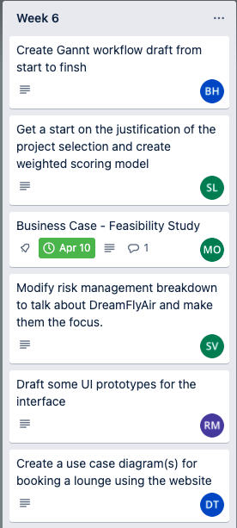

# Meeting minutes:

04/04/23 – 1 hour

|  |  |  |  |  |  |  |
| --- | --- | --- | --- | --- | --- | --- |
| **Member** | Bradley | Rhys | Mitch | Soham | Sourav | Huy |
| **Attendance**? |  |  |  |  |  |  |

Meeting times still being discussed, unattendance can be due to differing schedules.

# Meeting Minutes

Progress Report Summary

* Where each group member is up to with their allocated task.
* Quick questions about the tasks.
* Feedback on the work that has been completed.

Business Case discussion

* Discussion of existing business
  + Costs and benefits
  + Feasibility of the project

Project scope

* Discuss resources required for project.

Prototypes of user interface

* Discuss how it would look
* Discuss what elements would be on the page/s

New Task allocations

* Discuss what tasks you would like to do next or continue to complete.
* Group leader assigns tasks on Trello.

# Meeting discussion:

Progress Report Summary

* Everybody is clear on what they need to do. However, people need to complete their assigned tasks.
* Group members happy to use Trello for work assignment and to track progress.

Business Case discussion

* Further analysis was completed on the business and a feasibility study was created

Project scope

* All in agreeance to keep the system as simple as possible for the design to lay a foundation to work off.
* Focusing on a website for both desktop and mobile device is the goal, instead of having a separate mobile application.
* Gannt chat still under development for project scope

New Task allocations

* New tasks have been assigned to the different group members on Trello.
* Mitch is happy to focus on the business case, creating detailed feasibility study.
* Rhys is happy to focus on the front-end layout design and features
* Brad is going to focus creating a Gantt chart draft from start to finish
* Sourav is happy to start the justification of the project selection, mainly creating a weighted score model.

Random tasks have been assigned to members who didn’t attend.